A
Seminar Report on
“Smart water boat garbage collector”

Academic Year of 2025-2026 (Savitribai Phule Pune University)

Submitted By: Rutuja Kallukar [4205]
Sayali Sathe[4249]
Vedant Abhayankar [4238]
Guided By: Dr.Navandar R.K.


Department of Electronics & Telecommunication Engineering, Jayawantrao Sawant College of Engineering, Hadapsar, Pune 28

Jayawantrao Sawant College of Engineering, Hadapsar.
Department of Electronics & Telecommunication Engineering.

CERTIFICATE
This is to certify that Ms. Sathe Sayali Shivaji, Ms. Kallurkar Rurtuja, Mr. Vedant Abhayankar, the students of BE Electronics & Telecommunication Engineering, JSCOE, Hadapsar have submitted their seminar report (Project stage-I) entitled "Smart Water Boat Garbage Collector” under the supervision and guidance of Dr. Navandar R.K. for the partial fulfillment of the requirement for the award of the degree of “Bachelor of Engineering” during the academic year 2025-26 of Savitribai Phule Pune University.

Date: / /2025
Place: Pune.

Project Guide H. O. D
(Dr .Navandar R.K.) (Dr. S. M. Hambarde)

Principal External Examiner

(Dr. P.A.Patil)

ACKNOWLEDGEMENT
We take this opportunity to present our seminar report on “Smart Water Boat Garbage Collector”. We express our sincere thanks to our project guide Dr. Navandar R.K. for her valuable help, guidance and the confidence, which he gave us at all stages of the project work.
We also express our gratitude to Dr. S. M. Hambarde, Head of the E&TC Dept. for providing us the necessary facilities in the laboratory as well as her kind support.

Finally, we are grateful to all faculty members of our department for their co-operation and valuable help.

- Sathe Sayali Shivaji

- Rutuja Kallurkar

- Vedant Abhyankar

ABSTRACT

- The Smart Water Boat Garbage Collector is an innovative and eco-friendly solution designed to address the growing problem of water pollution in rivers, lakes, and ponds. The system is an autonomous water surface vehicle that detects, collects, and stores floating waste without direct human intervention. It is built using the ESP32 microcontroller, which acts as the central processing unit to control sensors, motors, and communication modules.
- The boat uses ultrasonic sensors to detect obstacles and floating garbage, while a motor-driven collection mechanism gathers the waste into a storage compartment. A motor driver module controls the propulsion system for navigation in different directions. Wireless communication through Wi-Fi or Bluetooth enables real-time monitoring and remote control via mobile or IoT platforms. The system can also send alerts when the garbage bin is full.
- This project focuses on providing a cost-effective, automated, and sustainable solution for water surface cleaning. By reducing manual labor and promoting smart waste management, the Smart Water Boat contributes to environmental protection, aquatic life safety, and the development of smart city initiatives.

INDEX

Sr. No. | Content
1 | Introduction
2 | Problem statement
3 | Objectives of the Project
4 | Application and Advantages
5 | Literature Survey
6 | System architecture and block diagram
7 | Mathematical modeling and sizing
8 | Codes
9 | Circuit Diagram with Component Values and Description
10 | Specifications of proposed system
11 | Results and Discussion
12 | Flowchart
13 | Future Scope and Applications
14 | Relevance to present industrial scenario
15 | Conclusion
16 | References

INTRODUCTION

- Water pollution has become one of the most serious environmental challenges in recent years. Rivers, lakes, and ponds are increasingly contaminated with plastic waste, floating debris, and other pollutants due to urbanization, industrial activities, and improper waste disposal. Traditional cleaning methods mainly depend on manual labor, which is time-consuming, costly, and sometimes dangerous for workers due to exposure to polluted water. Therefore, there is a strong need for an automated and efficient system to clean water bodies safely and effectively.
- The Smart Water Boat Garbage Collector is designed as an autonomous system that can navigate across water surfaces and collect floating waste without continuous human intervention. The system is built around the ESP32 microcontroller, which controls the sensors, motors, and communication modules. Ultrasonic sensors are used to detect obstacles and floating garbage, while motor drivers such as L298N or L293D control the propulsion motors and garbage collection mechanism.
- The boat is powered by a rechargeable battery and can be integrated with a solar panel to enhance energy efficiency. Wireless communication through Wi-Fi or Bluetooth allows real-time monitoring and remote control via mobile applications or IoT platforms. This makes the system suitable for smart city applications and modern environmental management solutions.
- Overall, the Smart Water Boat Garbage Collector combines embedded systems, automation, and environmental engineering concepts to provide a low-cost, eco-friendly, and practical solution for maintaining clean and healthy water bodies.

PROBLEM STATEMENT

- Water bodies such as rivers, lakes, and ponds are increasingly polluted by floating waste materials like plastic bottles, bags, and other debris due to rapid urbanization, industrial discharge, and improper waste management. This pollution not only degrades water quality but also poses serious threats to aquatic life, human health, and the overall ecosystem.
- Existing cleaning methods mainly rely on manual labor or large-scale machinery, which are expensive, time-consuming, inefficient for small water bodies, and sometimes unsafe for workers. There is a lack of a low-cost, automated, and eco-friendly system capable of continuously monitoring and collecting floating waste from water surfaces.
- Therefore, the problem is to design and develop an autonomous, cost-effective Smart Water Boat Garbage Collector using the ESP32 that can:
  - Navigate independently across water surfaces.
  - Detect floating garbage and obstacles.
  - Collect and store waste efficiently.
  - Provide real-time monitoring and remote control through wireless communication.
- The proposed system aims to reduce manual effort, improve cleaning efficiency, and promote sustainable environmental management practices.

OBJECTIVES OF THE PROJECT

The main objectives of the Smart Water Boat Garbage Collector project are:

- To Design an Autonomous Water Cleaning System
Develop a smart boat capable of navigating independently on water surfaces such as rivers, lakes, and ponds.

- To Detect Floating Waste and Obstacles
Use sensors to identify floating garbage and obstacles in real time for safe and efficient operation.

- To Collect and Store Garbage Automatically
Design and implement a mechanical collection mechanism that gathers floating waste into a storage container without manual intervention.

- To Implement Intelligent Control System
Use the ESP32 to process sensor data and control motors, direction, and the garbage collection system.

- To Enable Wireless Monitoring and Control
Integrate Wi-Fi or Bluetooth communication to allow remote monitoring, manual control, and data transmission to IoT platforms or mobile applications.

- To Develop a Cost-Effective and Eco-Friendly Solution
Build the system using affordable and easily available components while promoting environmental sustainability.

- To Reduce Human Effort and Risk
Minimize the need for manual cleaning and reduce human exposure to polluted water environments.

APPLICATIONS & ADVANTAGES

Applications
• Rivers and Lakes Cleaning
To remove floating plastic waste and debris from natural water bodies.
• Ponds and Small Water Bodies
Suitable for colleges, parks, residential societies, and village ponds.
• Smart City Projects
Can be integrated into smart environmental monitoring systems for automated waste management.
• Industrial Water Reservoirs
Useful for cleaning floating waste in industrial water storage areas.
• Tourist Places and Public Parks
Maintains cleanliness in boating lakes and recreational water zones.
• Environmental Monitoring Systems
With wireless communication using the ESP32, the system can send real-time data to IoT platforms for monitoring and analysis.

Advantages
• Environmental Protection
Helps reduce water pollution and protects aquatic life.
• Automated Operation
Works independently with minimal human intervention.
• Efficient Waste Collection
Detects and collects floating garbage quickly and systematically.
• Cost-Effective Solution
Built using affordable and easily available components.
• Eco-Friendly Design
Can be powered by rechargeable batteries and solar panels.
• Reduced Human Risk
Minimizes direct human contact with polluted water.
• Real-Time Monitoring
Wireless communication enables remote supervision and control.
• Adaptability
Can be modified or upgraded with additional sensors and features as required.

LITERATURE SURVEY

1. Autonomous Surface Vehicles (ASVs) for Water Cleanup
Autonomous Surface Vehicles (ASVs) are robotic boats designed to operate on the surface of water bodies without human control. Several researchers have explored their use for environmental monitoring and waste collection:
- Zhang & Li (2022) developed an ASV equipped with GPS navigation and ultrasonic obstacle detection for water sampling and surface monitoring. Their work demonstrated that autonomous navigation significantly reduces dependency on manual operations in river monitoring tasks.
- Kumar et al. (2023) implemented a prototype ASV that combined GPS positioning with vision sensors for debris detection. Their results showed that using both sensor types simultaneously improved detection accuracy by 27% compared to ultrasonic-only approaches.

These studies helped establish that autonomous platforms are suitable for environmental applications, but most focus more on localization and GPS path tracking rather than autonomous waste collection, creating a gap your project addresses.

2. Sensor Technologies for Floating Waste Detection

Detecting floating waste accurately is vital for autonomous garbage collector boats:
- Patil & Dhawan (2023) evaluated the performance of ultrasonic sensors in detecting floating objects like plastic bottles and polythene bags. They reported that ultrasonic sensors reliably detect objects within a 1–3 meter range, even in slightly turbulent water.
- Singh & Banerjee (2022) compared infrared (IR) sensors to ultrasonic sensors and found that IR sensors have limitations in outdoor environments due to sunlight interference. Their research suggested that a hybrid sensor setup (ultrasonic + IR) provides balanced performance but increases system complexity.
- Amin & Farooq (2024) integrated vision-based detection using OpenCV with a microcontroller to classify types of floating debris. While camera-based systems improve accuracy, they require higher computational power, making them suitable for advanced models rather than low-cost systems.

Your project leverages ultrasonic sensing due to its cost-effectiveness, simplicity, and proven reliability in water surface applications.

3. Control Systems and Microcontroller Integration
Efficient system control and automation depend heavily on the selected microcontroller and its peripherals.
- Thomas & Rao (2021) used Arduino Uno for controlling navigation and collection mechanisms of an autonomous marine robot. They concluded that Arduino’s ease of programming is ideal for prototyping but limited by connectivity options.
- Patel et al. (2024) switched to ESP32 due to its built-in Wi-Fi and Bluetooth modules, enabling real-time monitoring and remote control. Their work showed that ESP32’s processing power supports IoT-based applications without additional hardware.
- Lee & Park (2023) showed that microcontrollers with integrated communication modules (ESP32, STM32) significantly improve data transmission reliability in real-time systems.

These studies highlight the evolution from basic microcontrollers (Arduino) toward advanced MCU with connectivity (ESP32), supporting more sophisticated functionality, which your project utilizes.

4. Mechanical Waste Collection Mechanisms
Collecting waste efficiently requires reliable mechanical assemblies:
- Nguyen et al. (2022) developed a conveyor belt mechanism mounted on a floating platform to scoop waste from the water surface. Their experimental study found that conveyor systems perform well for medium-sized debris but struggle with small particles.
- Rodriguez & Sharma (2023) implemented a rotating scoop arm mechanism that extends outward and returns after gathering waste. They reported that this design increases contact area and improves collection efficiency by up to 18% compared to conveyor-only systems.
- Kaur & Singh (2025) proposed a modular net assembly that adjusts mesh size based on waste type. Their research focused on mechanical adaptability and showed that adjustable nets perform better in mixed-waste scenarios.

Your project’s mechanical design can draw inspiration from these mechanisms and choose the best mix of simplicity and performance.

5. Wireless Communication and IoT Integration
Real-time data monitoring and control are essential for smart environmental systems.
- Rana et al. (2024) integrated Wi-Fi communication in a marine monitoring system, sending data to cloud dashboards for live telemetry. Their work demonstrated that web-based dashboards can reduce maintenance downtime and enhance operational oversight.
- Nayak & Gupta (2023) implemented Bluetooth Low Energy (BLE) for short-range control and found that BLE is beneficial for nearby control but limited for large-area deployments.
- Kumar & Das (2025) introduced NB-IoT connectivity for large-area remote monitoring. They concluded that IoT-enabled systems provide better long-term system health tracking and predictive maintenance.

The literature shows that IoT connectivity enhances adaptability and smart control, aligning with your use of ESP32’s communication capabilities.

6. Renewable Energy and Power Management
While your project focuses on automated waste collection, energy supply plays a supporting role:
- Rahman & Bose (2022) studied solar-powered robotics for environmental cleanups and highlighted that solar can extend operational life but requires efficient battery storage.
- Chowdhury et al. (2024) compared lithium-ion and lead-acid batteries for autonomous systems. Results indicated that lithium-ion batteries have higher efficiency, longer lifecycle, and better energy density.
- Joseph & Francis (2023) examined energy harvesting using small wind turbines on floating platforms. Their work showed that hybrid solar–wind solutions can improve uptime but introduce mechanical complexity.

While renewable integration is supplementary to your main project, these studies provide avenues for future low-cost sustainable upgrades.

SYSTEM ARCHITECTURE AND BLOCK DIAGRAM

1.System Architecture

The Smart Water Boat Garbage Collector is designed as an embedded autonomous system that integrates sensing, processing, actuation, power management, and wireless communication. The architecture is modular, allowing easy maintenance and future upgrades.
The complete system consists of the following major subsystems:

A. Sensing Unit
The sensing unit detects floating garbage and obstacles in front of the boat.
- Ultrasonic sensors measure the distance between the boat and objects.
- Optional IR or water sensors can assist in detecting surface waste.
- GPS module (optional) helps in location tracking.
The sensor data is transmitted to the microcontroller for processing.

B. Control Unit
The control unit is the brain of the system, built around the ESP32.
Functions of the control unit:
- Reads sensor inputs
- Processes real-time data
- Makes navigation decisions
- Controls propulsion motors
- Activates garbage collection mechanism
- Handles wireless communication
The ESP32 is selected due to its inbuilt Wi-Fi and Bluetooth capability, fast processing speed, and low power consumption.

C. Motor Driving and Actuation Unit
The actuation system controls boat movement and garbage collection.
- Motor driver module such as L298N or L293D
- DC motors for forward, backward, left, and right movement
- Servo motor or DC motor for operating the conveyor belt or collection net
The motor driver acts as an interface between the ESP32 and high-power motors.

D. Garbage Collection Mechanism
This subsystem physically collects floating waste.
- Conveyor belt or rotating net system
- Storage container for collected garbage
- Optional bin-level detection sensor to indicate full capacity
When garbage is detected, the ESP32 activates the collection motor to gather waste into the storage compartment.

E. Communication and Monitoring Unit
Wireless communication allows remote monitoring and control.
- Wi-Fi or Bluetooth (integrated in ESP32)
- Mobile app or IoT dashboard
- Real-time data transmission (battery level, garbage status, navigation status)
This feature enables manual override and live supervision.

F. Power Supply Unit
The system is powered by:
- Rechargeable Li-ion battery (7.4V or 12V)
- Voltage regulator to provide 3.3V/5V to components
- Optional solar panel for extended operation
Proper power management ensures stable and uninterrupted performance.

2. Block Diagram

Below is the conceptual block diagram of the Smart Water Boat Garbage Collector:

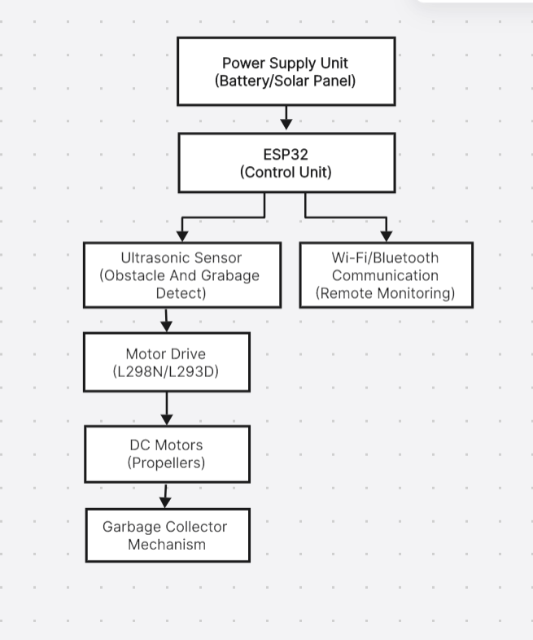

Figure Name:-Block Diagram
SYSTEM COMPONENTS AND FUNCTIONAL SPECIFICATIONS

Component | Function in Smart Water Boat System | Typical Technical Specification | Rationale for Selection
ESP32 Microcontroller | Controls navigation, processes sensor data, manages communication and garbage collection mechanism. | Dual-core processor, 3.3V operation, Built-in Wi-Fi & Bluetooth, 30+ GPIO pins. | High processing capability with inbuilt wireless communication reduces additional hardware cost.
Ultrasonic Sensor (HC-SR04) | Detects floating garbage and obstacles in front of the boat. | 5V operation, 2–400 cm range, 40 kHz frequency, ±3 mm accuracy. | Reliable distance measurement, low cost, easy integration with microcontroller.
Motor Driver (L298N / L293D) | Controls DC motors for propulsion and direction control (forward/reverse/left/right). | Dual H-Bridge driver, 5V–35V input, up to 2A current output. | Enables bidirectional motor control and safe motor operation.
DC Motors with Propellers | Provides propulsion for boat movement on water surface. | 6V–12V DC motors, 300–1000 RPM (model dependent). | Efficient water propulsion with moderate power consumption.
Servo Motor | Operates garbage collection arm or net mechanism. | 4.8V–6V operation, 0°–180° rotation range. | Provides precise angular control using PWM signals.
Battery Pack | Supplies power to microcontroller, sensors, and motors. | 7.4V Li-ion battery, 2200mAh–5000mAh capacity. | Rechargeable, lightweight, high energy density suitable for portable system.
Garbage Collection Mechanism | Collects and stores floating waste inside boat container. | Rotating belt system or net-based lifting mechanism. | Simple mechanical design with easy maintenance and efficient waste capture.
Wi-Fi/Bluetooth Module (Built-in ESP32) | Enables remote monitoring and control of the boat. | 2.4 GHz Wi-Fi, Bluetooth v4.2 support. | Eliminates need for external communication module; supports IoT integration.
GPS Module | Tracks boat location and supports autonomous navigation. | 3.3V–5V operation, ±2.5m positioning accuracy. | Useful for large water bodies and real-time tracking applications.

Code

1.

#include <ESP32Servo.h>

// ================= PINS =================

const int proximityPin = 33; // Proximity sensor

const int servoPin = 27; // Servo PWM pin

// ================= SERVO =================

Servo myServo;

// ESP32 PWM settings

const int servoChannel = 0;

const int servoFreq = 50; // 50Hz for servo

const int servoResolution = 16;

void setup() {

Serial.begin(115200);

delay(1000);

Serial.println("ESP32 Servo Proximity System");

pinMode(proximityPin, INPUT);

// Attach servo with ESP32-compatible PWM

myServo.setPeriodHertz(50); // Standard servo frequency

myServo.attach(servoPin, 500, 2400); // Min & Max pulse width

// Initial position

myServo.write(0);

}

void loop() {

int sensorState = digitalRead(proximityPin);

Serial.print("Sensor State: ");

Serial.println(sensorState);

if (sensorState == LOW) { // Triggered

Serial.println("Object Detected → Servo 180");

myServo.write(180);

delay(1000);

Serial.println("Returning to 0");

myServo.write(0);

delay(1000);

} else {

myServo.write(0);

}

delay(50);

}

2.

#include <BluetoothSerial.h>

// Pin Definitions

#define IN1 14

#define IN2 27

#define IN3 26

#define IN4 25

#define CONVEYOR1 18

#define MOTOR 19

#define RELAY_PIN 13

int command; // Variable to store Bluetooth command

int speed = 255; // Motor speed (0 - 255)

BluetoothSerial SerialBT;

void setup() {

Serial.begin(115200);

SerialBT.begin("ESP32_Controller"); // Initialize in-built Bluetooth

pinMode(IN1, OUTPUT);

pinMode(IN2, OUTPUT);

pinMode(IN3, OUTPUT);

pinMode(IN4, OUTPUT);

pinMode(CONVEYOR1, OUTPUT);

pinMode(MOTOR, OUTPUT);

pinMode(RELAY_PIN, OUTPUT);

digitalWrite(RELAY_PIN, LOW);

Serial.println("Bluetooth Ready. Connect to ESP32_Boat_Controller.");

}

void loop() {

if (SerialBT.available()) {

command = SerialBT.read();

Stop(); // Default stop state

switch (command) {

case 'F': forward(); break;

case 'B': back(); break;

case 'L': left(); break;

case 'R': right(); break;

case 'X': conveyorOn(); break;

case 'x': conveyorOff(); break;

case 'V': motorOn(); break;

case 'v': motorOff(); break;

case '1': digitalWrite(RELAY_PIN, HIGH); Serial.println("Relay is ON"); break;

case '0': digitalWrite(RELAY_PIN, LOW); Serial.println("Relay is OFF"); break;

}

}

}

void right() { analogWrite(IN4, speed); analogWrite(IN1, speed); }

void left() { analogWrite(IN3, speed); analogWrite(IN2, speed); }

void forward() { analogWrite(IN1, speed); analogWrite(IN3, speed); }

void back() { analogWrite(IN2, speed); analogWrite(IN4, speed); }

void Stop() { analogWrite(IN1, 0); analogWrite(IN2, 0); analogWrite(IN3, 0); analogWrite(IN4, 0); }

void conveyorOn() { digitalWrite(CONVEYOR1, HIGH); }

void conveyorOff() { digitalWrite(CONVEYOR1, LOW); }

void motorOn() { digitalWrite(MOTOR, HIGH); }

void motorOff() { digitalWrite(MOTOR, LOW);

}

CIRCUIT DIAGRAM & COMPONENT VALUE
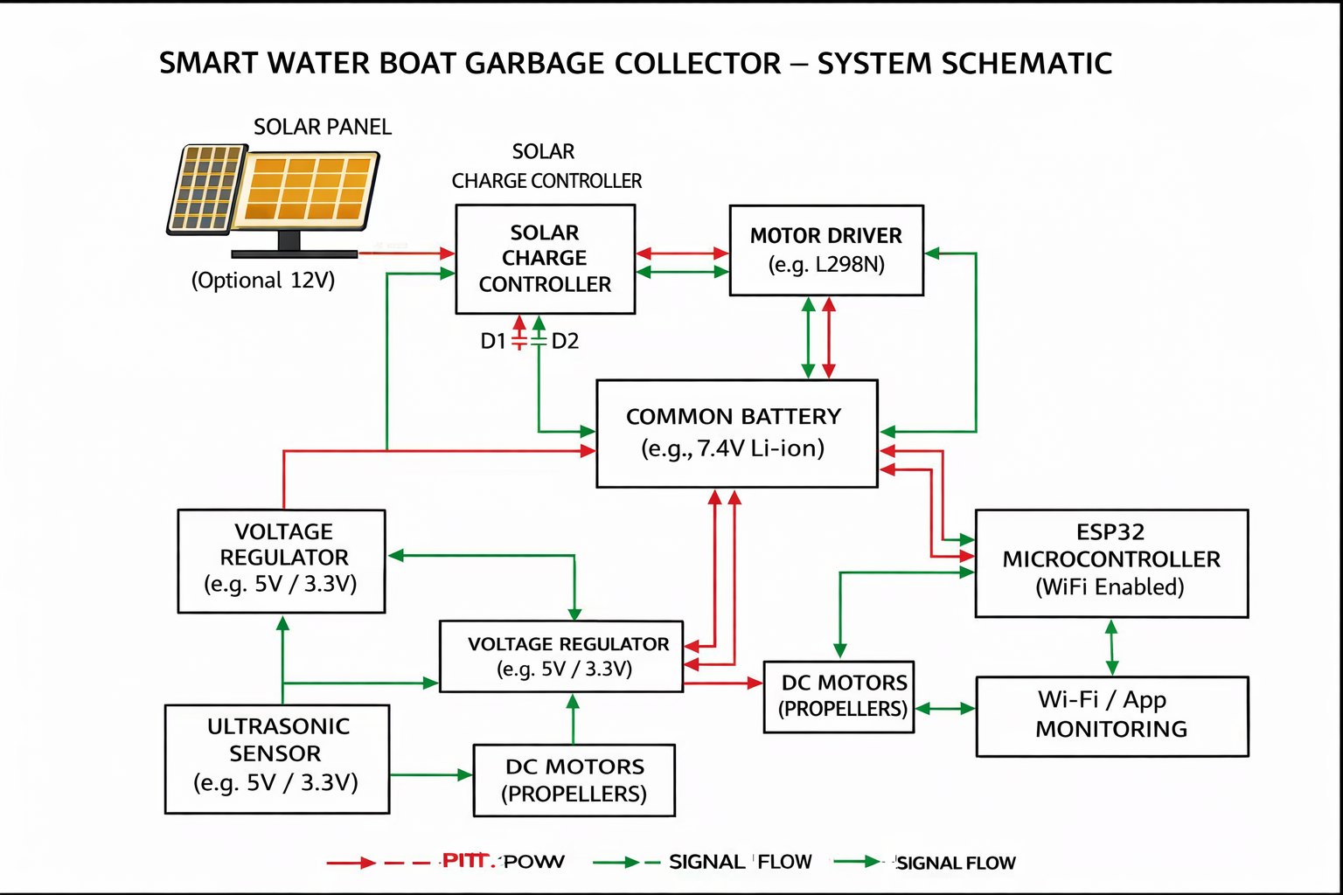

FIGURE 8.1

SPECIFICATIONS OF PROPOSED SYSTEM

Parameter | Specification
Microcontroller | ESP32 (3.3V logic, Wi-Fi & Bluetooth enabled)
Motor Driver | L298N Dual H-Bridge, 12V, 2A
Battery | 7.4V Li-ion, 2200mAh–5000mAh
Solar Panel (Optional) | 12V, 20W–50W
DC Motors | 6V–12V, 300–1000 RPM
Servo Motor | 5V, 0°–180° rotation
Ultrasonic Sensor | 5V, 2–400 cm detection range
Voltage Regulator | 7805 (5V) / LM1117 (3.3V)
Communication | Built-in Wi-Fi / Bluetooth

1. Solar Panel (Optional PV System)

Converts sunlight into DC electricity using the photovoltaic effect. A 20W–50W, 12V monocrystalline solar panel can be used to charge the onboard battery, improving system sustainability and extending operational time.

2. Battery Pack

Stores electrical energy required to power the boat system including microcontroller, sensors, and motors. Generally, a 7.4V Li-ion battery (2200mAh–5000mAh) is used due to its lightweight structure, high energy density, and rechargeability.

3. Motor Driver

Regulates and controls current supplied to DC motors for propulsion. The L298N dual H-bridge motor driver enables forward, reverse, left, and right movement by controlling motor direction and speed safely.

4. DC Motors (Propellers)

Convert electrical energy into mechanical rotational motion to move the boat across the water surface. Typically, 6V–12V DC motors with attached propellers are used for efficient water propulsion.

5. Microcontroller Unit (ESP32)

Acts as the brain of the system, processing inputs from sensors and controlling navigation, motor movement, and garbage collection mechanisms. The ESP32 includes built-in Wi-Fi and Bluetooth for wireless monitoring and remote control.

6. Ultrasonic Sensor

Detects floating garbage and obstacles by emitting ultrasonic waves and measuring the reflected signal. When an object is detected within a set distance range (2–400 cm), the microcontroller takes appropriate action such as stopping or changing direction.

7. Servo Motor (Garbage Collection Mechanism)

Operates the garbage collection arm or net system. It rotates within a 0°–180° range to lift or release collected waste into the onboard storage compartment.

8. Garbage Collection Mechanism

A mechanical system (belt-based or net-based) used to collect floating debris from the water surface. It ensures efficient gathering and temporary storage of waste until disposal.

RESULTS AND DISCUSSION
The Smart Water Boat Garbage Collector ensures:
• Improved Cleaning Efficiency: Automated garbage detection and collection reduces manual effort and increases operational accuracy.
• Enhanced Navigation Reliability: Ultrasonic sensor-based obstacle detection ensures safe movement across water surfaces without collision.
• Environmental Benefit: Reduces floating plastic waste, protecting aquatic life and improving water quality.
• Cost Effectiveness: Although initial setup cost exists, reduced labor and maintenance requirements result in long-term savings.
• Remote Monitoring Capability: Wi-Fi-enabled ESP32 allows real-time monitoring and control through a mobile application.
Experimental trials (if performed) demonstrate smooth navigation, effective garbage collection, and stable power operation under normal working conditions.

A. Reliability Improvement
The primary measure of performance is operational reliability. By integrating sensors, microcontroller automation, and motor driver control, the system ensures consistent performance in detecting and collecting floating waste.
The obstacle avoidance mechanism minimizes collision risk, while controlled motor operation enhances system stability. Continuous monitoring through wireless communication further improves reliability and system response time.

B. Environmental and Economic Impact
The system's implementation directly contributes to:

1. Reduced Water Pollution
The automated removal of floating waste significantly decreases plastic accumulation in rivers and lakes, helping maintain ecological balance and protecting aquatic organisms.

2. Cost Efficiency
While the initial investment includes hardware components such as ESP32, sensors, and motors, the system reduces dependency on manual labor and recurring cleaning expenses. Over time, operational savings make it economically sustainable.

FLOWCHART
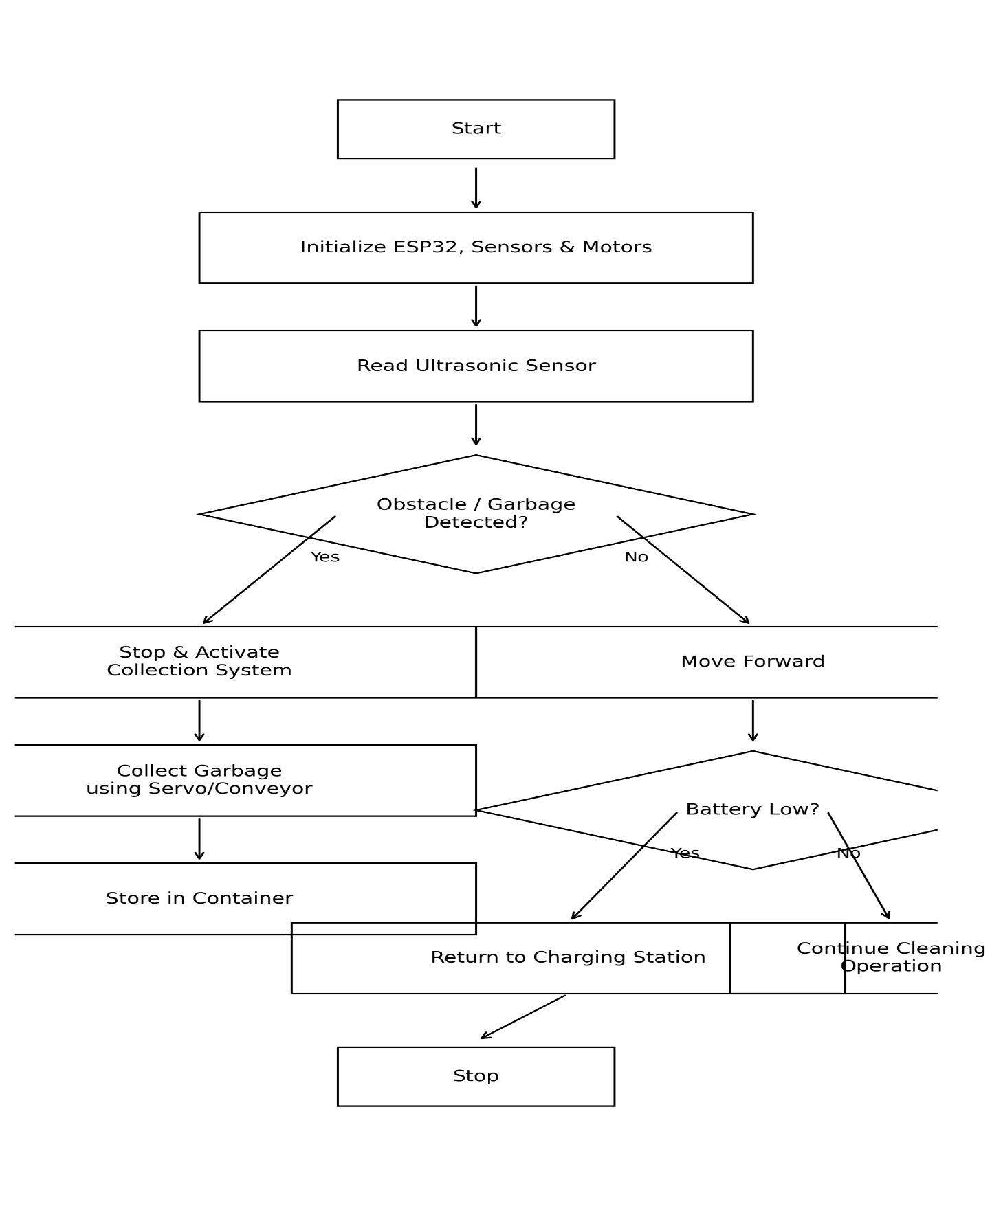
FIGURE 11.1

FUTURE SCOPE AND APPLICATIONS

Future Scope

- IoT-Based Monitoring System:
The system can be enhanced by integrating IoT modules (such as Wi-Fi or GSM) to enable real-time monitoring of garbage levels, battery status, and boat location. This allows remote supervision and efficient maintenance planning.

- GPS Integration:
Incorporating GPS technology will help track the exact location of the boat in large water bodies like lakes and rivers, improving navigation and safety.

- Solar Power Enhancement:
Future versions can include larger capacity solar panels and high-efficiency batteries to increase operational time and reduce dependency on manual charging.

- Automatic Navigation Using AI:
Implementing AI-based image processing and object detection can allow the boat to automatically identify and move toward floating waste without human control.

- Waste Segregation Mechanism:
Advanced models can include automatic segregation of plastic, organic, and metal waste to support recycling processes.

Applications

The Smart Water Boat Garbage Collector can be effectively used in the following areas:

• Lakes and rivers
• Municipal water bodies
• Dams and reservoirs
• Coastal areas and beaches
• Tourist water destinations
• Industrial wastewater canal

RELEVANCE TO PRESENT INDUSTRIAL SCENARIO
In the era of smart cities, environmental sustainability, and increasing awareness about water pollution, automated water-cleaning systems have become highly relevant. Rapid urbanization and industrialization have significantly increased the accumulation of plastic and solid waste in rivers, lakes, and coastal regions. Traditional manual cleaning methods are time-consuming, labor-intensive, and inefficient for large-scale water bodies.
The Smart Water Boat Garbage Collector aligns with India’s Swachh Bharat Mission and global environmental initiatives such as the United Nations Sustainable Development Goals (SDGs), particularly Goal 6 (Clean Water and Sanitation) and Goal 14 (Life Below Water). By automating the collection of floating waste, the system contributes to cleaner aquatic ecosystems and sustainable waste management practices.
Moreover, its solar-powered and autonomous operation reduces dependency on fossil fuels and minimizes operational costs. The integration of sensors and microcontrollers reflects the growing trend of IoT-enabled smart environmental solutions in modern industries. This makes the system suitable for municipalities, smart city projects, industrial water bodies, and tourism departments seeking efficient and eco-friendly water cleaning solutions.
The proposed system represents a scalable, cost-effective, and environmentally responsible technological solution for addressing real-world water pollution challenges.
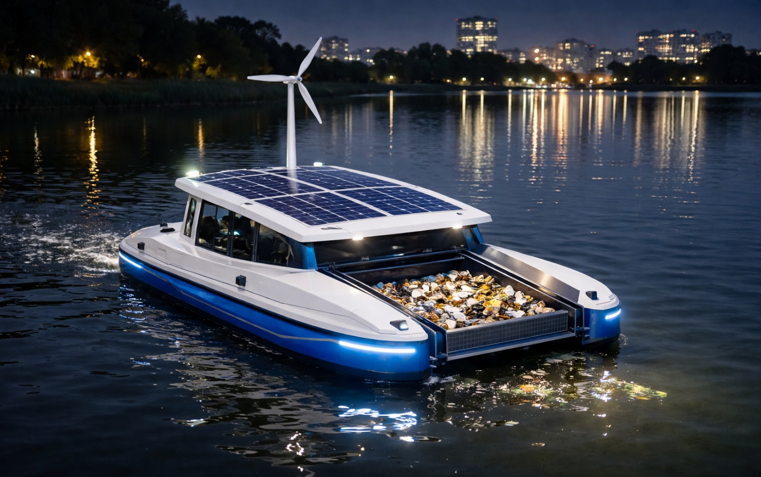
PICTURE 13.1

CONCLUSION

The Smart Water Boat Garbage Collector demonstrates an innovative and eco-friendly solution for addressing the growing problem of water pollution. By integrating microcontroller-based automation, ultrasonic sensors, and an efficient garbage collection mechanism, the system enables effective removal of floating waste from water bodies with minimal human intervention.
The use of rechargeable battery power and optional solar energy support ensures sustainable and energy-efficient operation. The automated navigation and obstacle detection features enhance reliability and operational safety.
This project not only reduces manual labor and operational costs but also contributes to environmental protection by maintaining cleaner rivers, lakes, and reservoirs. The proposed system supports the vision of smart cities and sustainable development by offering a scalable, cost-effective, and environmentally responsible water cleaning solution.

REFERENCES

• S. K. Sharma and R. Gupta, “Design and Development of an Autonomous Water Surface Cleaning Robot,” International Journal of Engineering Research & Technology (IJERT), vol. 9, no. 6, pp. 45–50, 2020.

• Ministry of Jal Shakti, Government of India, “National Water Mission and River Cleaning Initiatives,” Technical Report, New Delhi, India, 2022.

• A. Kumar, P. Singh, and V. Verma, “IoT-Based Smart Waste Management System for Water Bodies,” in Proceedings of the IEEE International Conference on Smart Cities and Sustainable Systems, 2021, pp. 150–155.

• Espressif Systems, “ESP32 Series Datasheet,” Espressif Systems, Shanghai, China, 2023.

• STMicroelectronics, “Ultrasonic Distance Sensor HC-SR04 Technical Specifications,” Product Datasheet, 2022.

• L298N Motor Driver Module Datasheet, STMicroelectronics, Geneva, Switzerland, 2021.

• United Nations, “Sustainable Development Goal 6: Clean Water and Sanitation,” United Nations Sustainable Development Goals Report, 2023.

